Newport Inglewood Fault
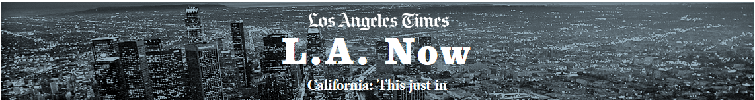

Big L.A. earthquake could cause beach areas to sink up to 3 feet in seconds, new study finds
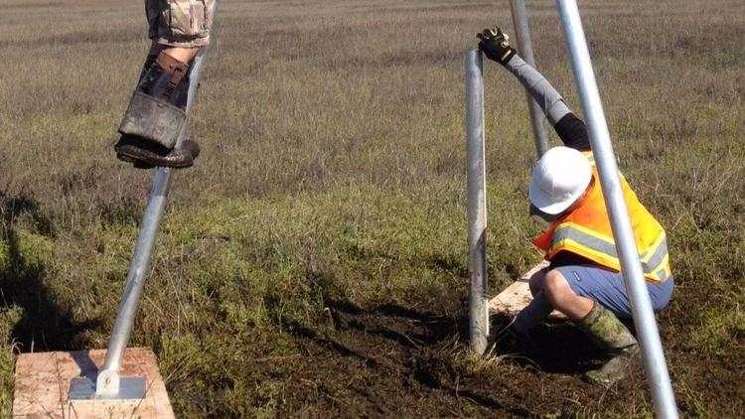

Researchers insert a pipe deep into sediment to extract a cross section to determine the seismic history of the Seal Beach area. (Cal State Fullerton)

Rong-Gong Lin II Contact Reporter
One of Southern California’s most dangerous faults caused land on the Orange County coast to sink between 1½ feet to 3 feet in a matter of seconds during prehistoric earthquakes, according to a new study that suggests the seismic risk is greater than previously believed.
“It’s not just a gradual sinking. This is boom — it would drop. It’s very rapid sinking,” said the lead author of the report, Robert Leeper, a geology graduate student at UC Riverside who worked on the study as a Cal State Fullerton student and geologist with the U.S. Geological Survey.
ADVERTISING
The study of the Newport-Inglewood fault focused on the wetlands of Seal Beach. But the area of sudden dropping could extend to other regions in the same geologic area of the Seal Beach wetlands, which includes the U.S. Naval Weapons Station and the Huntington Harbour neighborhood of Huntington Beach.
Related: Southern California's deadliest quake may have been caused by oil drilling, study says
Leeper and a team of scientists at Cal State Fullerton had been searching the Seal Beach wetlands for evidence of ancient tsunami. Instead, they found buried organic deposits that they determined to be the prehistoric remains of marsh surfaces, which they say were abruptly dropped by large earthquakes that occurred on the Newport-Inglewood fault.
Those earthquakes, roughly dated in 50 BC, AD 200 and the year 1450 — give or take a century or two — were all more powerful than the magnitude 6.4 Long Beach earthquake of 1933, which did not cause a sudden drop in the land, Leeper said.
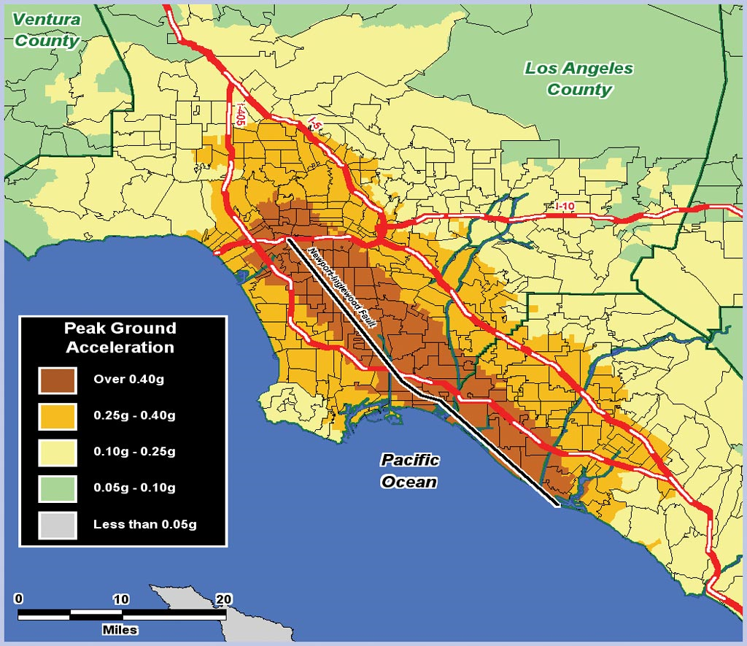
Peak Ground Acceleration, measured in relation to the force of gravity, is one measure of how an earthquake will impact a building. Wood-frame buildings are designed to withstand 0.4 g's of lateral force. The brown areas in the map above shows where wood-frame single-family homes could be expected to collapse when it was thought that the Newport-Inglewood Fault was only capable of smaller magnitude quakes. The new findings may indicate that the Collapse Zone could extend to the orange area as well. - Pope.
As a result, the observations for the first time suggest that earthquakes as large as magnitudes 6.8 to 7.5 have struck the Newport-Inglewood/Rose Canyon fault system, which stretches from the Westside of Los Angeles through Long Beach and the Orange County coast to downtown San Diego.
The newly discovered earthquakes also suggest that the Newport-Inglewood fault is more active than previously thought. Scientists had believed the Newport-Inglewood fault ruptured in a major earthquake once every 2,300 years on average; the latest results show that a major earthquake could come once every 700 years on average, Leeper said.
It’s possible the earthquakes can come more frequently than the average, and can arrive spaced as little as 300 years apart from one another.
If a magnitude 7.5 earthquake did rupture on the Newport-Inglewood/Rose Canyon fault system, such a temblor would bring massive damage throughout Southern California, said seismologist Lucy Jones, who was not affiliated with the study. Such an earthquake would produce 45 times more energy than the 1933 earthquake.
“It’s really clear evidence of three earthquakes on the Newport-Inglewood that are bigger than 1933,” Jones said of the earthquake that killed 120 people. “This is very strong evidence for multiple big earthquakes.”
The idea that the Newport-Inglewood fault could produce more powerful earthquakes than what happened in 1933 has been growing over the decades. Scientists have come to the consensus that the Newport-Inglewood fault could link up with the San Diego County coast’s Rose Canyon fault, producing a theoretical 7.5 earthquake based on the length of the combined fault system.
An earthquake of magnitude 7 on the Newport-Inglewood fault would hit areas of Los Angeles west of downtown particularly hard.
“If you’re on the Westside of L.A., it’s probably the fastest-moving big earthquake that you’re going to have locally,” Jones said. “A 7 on the Newport-Inglewood is going to do a lot more damage than an 8 on the San Andreas, especially for Los Angeles.”
The study focused on taking samples of sediment underneath the Seal Beach National Wildlife Refuge in 55 locations across a broad zone, mapping buried layers for signs of past seismic activity.
To do this, scientists used a vibrating machine to push down a 20-foot-long, sharp-tipped pipe into the sediment and extract sediment samples that gave them a look at what has happened geologically underneath the site.
They found a repeating pattern where living vegetation on the marsh suddenly dropped by up to 3 feet, submerging it underwater, eventually killing everything on the surface and later buried.
“We identified three of these buried layers [composed of] vegetation or sediment that used to be at the surface,” Leeper said. “These buried, organic-rich layers are evidence of three earthquakes on the Newport-Inglewood in the past 2,000 years.”
Earthquakes elsewhere have also caused sudden drops in land, such as off the Cascadia subduction zone along the coast of Oregon and Washington. There, pine trees that once grew above the beach suddenly dropped below sea level, killing the trees as salt water washed over their roots, said study coauthor Kate Scharer, a USGS research geologist.
Another reason pointing to major earthquakes as a cause is the existence of a gap — known as the Sunset Gap — in the Newport-Inglewood fault that roughly covers the Seal Beach National Wildlife Refuge and Huntington Harbour.
The gap is oriented in a way that, if a major earthquake strikes, land could suddenly drop. Such depressions have formed in other Southern California faults, which have created Lake Elsinore from the Elsinore fault, and created Quail Lake, Elizabeth Lake and Hughes Lake from the San Andreas fault, Jones said.
While the scientists focused their study on the Seal Beach wetlands, because Huntington Harbour and the Naval Weapons Station area also lie in the same gap of the Newport-Inglewood fault, it could be possible that the sinking would extend to those areas as well, Leeper said.
But further study would be a good idea for those areas. It’s possible that an investigation of Huntington Harbour, for instance, would show that land underneath it did not drop during earthquakes but moved horizontally, like much of the rest of the Newport-Inglewood fault, Scharer said.
Sudden dropping of land could cause damage to infrastructure, Scharer said, such as roads or pipes not designed to handle such a rapid fall.
Nothing in the new study offers guidance for when the next major earthquake on the Newport-Inglewood fault will strike next. “Earthquakes can happen at any time. We can’t predict them. All we can do is try to understand how often they occur in the past, and be prepared for when the next one does occur,” Leeper said.
Scientists generally say that the chances of a major quake on the San Andreas fault are higher in our lifetime because that fault is moving so much faster than the Newport-Inglewood, at a rate of more than 1 inch a year compared with a rate of one-twenty-fifth of an inch a year.
But it’s possible a big earthquake on the Newport-Inglewood fault could happen in our lifetime.
The study was published online Monday in Scientific Reports, a research publication run by the journal Nature.
Besides Leeper and Scharer, the other coauthors of the study are Brady Rhodes, Matthew Kirby, Joseph Carlin and Angela Aranda of Cal State Fullerton; Scott Starratt of the USGS; Simona Avnaim-Katav and Glen MacDonald of UCLA; and Eileen Hemphill-Haley.
To read the article in Spanish, click here
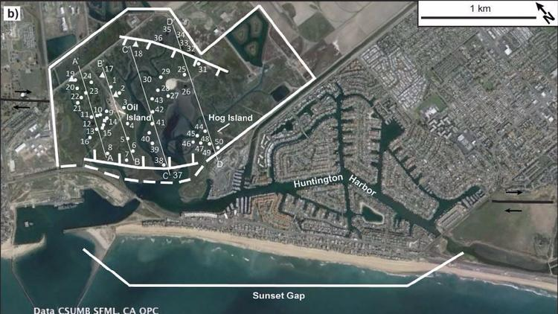

Researchers studied prehistoric layers of sediment in a gap of the Newport-Inglewood fault known as the Sunset Gap. They took sediment samples from 55 locations that suggest the land in this region suddenly dropped by as much as 3 feet during major earthquakes. (Cal State Fullerton / Scientific Reports)

